#### About Me

I was born in Melbourne, Victoria in 1988, I am currently 32 years of age, I have two kids a boy & girl.   
Languages: English   
Nationality: Australian

#### Personal Profile

I Personally do no put much stock in these online tests, as I do not believe they are completely accurate and nothing is stopping you cherry picking your answers to manipulate the outcome, however they can be fun to do with friends or fellow employee’s.  
  
 In these tests I answered as truthfully without sugar coating it. So, I could get an accurate result am I do recognize some of the traits pointed out, in the three selected tests.

###### Personality Test:

The results from the personality test were interesting to me as, I quite enjoy overseeing projects and building up the confidence of me team or work colleagues to get the best outcome. Charisma and confidence; when I am talking about a project or work presentation, I am fine, but if it's just meeting new people, I am lousy and awkward.  
  
 I am well driven and determined to achieve any goals that have been set for me, but I would not say I have a ruthless level of rationality.  
  
 I agree with the remainder of the explanations of my personality type listed.

###### Creativity Test:

I kind of agree with this test as I do not see myself as overly creative in a visual sense as in drawing or design, however I am quite good at coming up with creative ways to overcome complex technical and/or design issues.

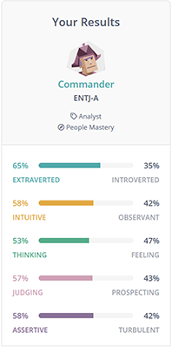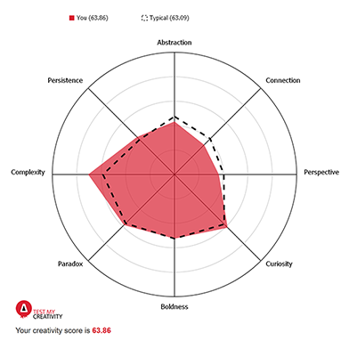

###### Learning Style:

This test pointed out that I am a visual learning which I most definitely am. I rather see examples or be shown, than someone talk on and on for an hour or so, our class wide seminars I find extremely boring and lacking substance to keep my attention.

I also like to learn by pulling things apart be it equipment or source code to understand how its work and its design as I find that a great learning tool for electronics and programming.

Once shown I can normally rinse and repeat with no issue.

